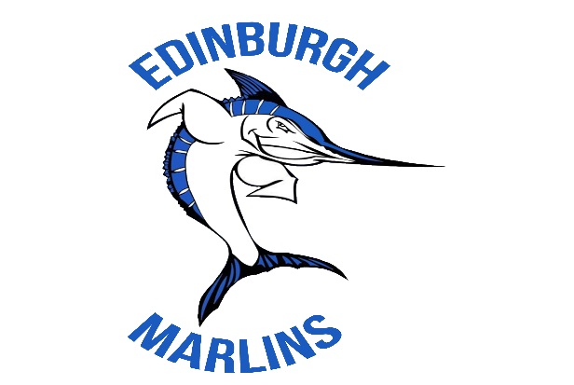
SWIM TEAM REGISTRATION 2016

http://edm.swim-team.us

Team Chairpersons:

Holly Reeves 404-661-1249 hollyreeves@charter.net
Matt Reeves 770-331-1405 reevesmatt@charter.net

Registration days are scheduled on Sunday, February 28, from 1- 5pm (Edinburgh Residents Only from 1-3pm) & Sunday, March 13, 1- 5pm at the Edinburgh Residents Clubhouse. If you cannot attend the registration days, please mail your forms prior to April 8th to avoid a late fee.
The following items are required for registration:

- 2016 Registration Form
- Gwinnett County Swim League Waiver
- Athlete/Parent Concussion Awareness Form
- Medical Release Form
- Volunteer Registration Form
- If you have a new swimmer, you will need to submit a photocopy of his/her birth certificate, and show the original copy to a board member.

Requirements for New Swimmers: To be a member of the team, a child must be no older than 18 on June 1, 2016, and must be able to swim above water approximately 5 to 10 lengths of the pool during a 30 minute practice session. All registrants will be given until May 19th, our practice meet, to meet this swimming requirement. This guideline was developed to ensure the safety of the children, and allow us to best utilize our coaching resources. If you are uncertain of whether your child will satisfy the swimming requirement, we encourage you to register him/her for the team and then enroll in swim lessons prior to the start of the season.
Minimum Swim Meet Requirement: We require swimmers to attend/swim a minimum of 3 swim meets to participate on our team. We realize that swimmers may have various conflicts with some meets from other sports and/or family travel. However, for our team to be competitive we need swimmers at as many meets as possible. If you cannot meet this requirement, please reconsider your registration.

Mandatory Team Fundraiser Photos: Support our team and get digital images of your children to remember the season $20/family. Photo day with professional photographer TBD. You will receive a digital download of individual shots, and a team photo via email. Then you can do whatever you choose... print images, have them made into fun buttons, posters, etc.
Swimsuits: Team swimsuits are required to swim with our team. We expect all swimmers to wear their team suit at all swim meets during the season. Suits will be available for sizing and purchase at registration.

Volunteers: We require an army of volunteers to run this swim team, and we appreciate the time that our families contribute. As you prepare to register, please consider how you might serve the team this year.
If you have friends interested in joining the Edinburgh Marlins please let us know and we will send them registration packets. We look forward to a fantastic season!

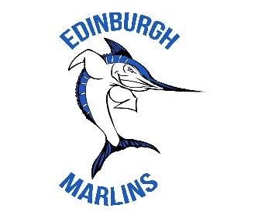

SUMMER 2016 DATES & CONTACTS – Preliminary (2/20/2016)

Swim Team Communication
2016 Meet Schedule
Meets begin at 6:00 pm
Check schedule each week for arrival & warm-up times
GCSL Championship Meet at Georgia Tech
(For qualified swimmers)
Saturday, July 9
Sunday, July 10
Sessions TBD
Sessions TBD
Email and Text Messaging:
The majority of our communication will be via e-mail and text messaging. Please make sure we have your correct e-mail address(es) and phone number. It will be the responsibility of the parent(s) and/or swimmer(s) to sign up for the text alert.
Thursday, May 19 | Home | Mock | Mock Meet*
TBD | TBD | TBD | TBD
TBD | TBD | TBD | TBD
TBD | TBD | TBD | TBD
TBD | TBD | TBD | TBD
TBD | TBD | TBD | TBD
TBD | TBD | TBD | TBD

Website: http://edm.swim-team.us
Our team website includes information about the team, including our practice and meet times, directions, and swimmers’ times from each meet.

Mail Folders:
Each swim team family, and coach has a mail folder at the pool. Please check these regularly for team communications and ribbons.

Parent Meeting – Monday, May 2. This meeting will review all of the important information about the team. Team apparel available for sale. The meeting will take place at Bear’s Best in Edinburgh from 7-8pm. We will send reminders closer to the event.
Practice Times

After School Schedule – May 9- 20 4:00- 6:30 pm
Summer Practice Schedule– begin May 26 7:30-11:00am
Note: No practice on May 30 (Memorial Day) or July 4

County Meet Team Practice – beginning July 1
(For swimmers who qualify for the GCSL Championship Meet)
July 1-8 9:30 – 11:00 am (tentative)
May 12- 21 | 6 & Under | 4:00 – 4:30 pm
 | Elementary | 4:30 – 5:30 pm
 | Middle & HS | 5:30 – 6:30 pm

5/23- 7/1 | 6 & Under | TBD
 | 7/8 & 11/12 | TBD
 | 9/10 & 13/18 | TBD

*Mock Meet (Practice Meet)-Thursday, May 19. Meet begins at 6pm, with warm up at 5:15pm.
This will be run as a regular meet and assist in establishing accurate times needed for Gwinnett County Swim League procedures. Volunteers will be needed, and will have an opportunity to learn their jobs for the season. Team apparel available for sale.
Evening Practices
Monday & Wednesdays from 6/1-6/29
These practices are intended for swimmers with working parents or those that will miss the entire week of practice due to camp, VBS, etc. Please sign up in advance so we know how many coaches are needed.

6:00-7:00 pm

Morning Marlin Madness – This will be held at the morning practice following each of the team meets. We will gather to celebrate a great meet, have a practice and enjoy some fun together. (May 27, June 3, 10, 17, 24, July 1)
Contact Information:

Swim Team Committee Members:
Holly Reeves, Chairperson hollyreeves@charter.net
Matt Reeves, Chairperson reevesmatt@charter.net
Kim McCarthy, Coaching 4themccarthys@att.net
Tanya Burnley, Treasurer tnt_burnley@bellsouth.net
Julie Shingadia, Fundraising julieshingadia@gmail.com
Tonya Oliver, Meet Mgr oliverswimmom@gmail.com Kim Briley, Merchandise/ Spirit kimbriley@charter.net
Amy Gundry, Communications amygundry@yahoo.com

Websites:
Team Website: GCSL Website:
http://edm.swim-team.us
www.gwinnettswimleague.com

Picture Day – Date: June 3, 2016 9am
Individual & Team Pictures, please make sure that each swimmer is in their Edinburgh Swim Team suit.

End of Season Celebration & Awards – Sunday, July 31, 2016- 7-8pm, located at Bear’s Best Clubhouse. More details to follow throughout the season.

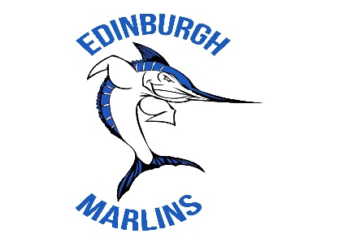

2016 REGISTRATION FORM

Please return completed forms at Registration Days on February 28 and March 13 or mail to: Holly Reeves, 5034 Brendlynn Dr, Suwanee, GA 30024
If this is your child’s first year swimming in the Gwinnett County Swim League (GCSL), you must:
  - Include a copy of his/her birth certificate AND
  - Show the original birth certificate to a Board Member (preferably at Registration Days).

Swimmer’s Last Name | First Name | Birthday | Sex | Returning EDM Swimmer | Fees | Total
Swimmers 12 and under as of 6/1/16:
1. |  | / / | M / F | Y / N | $140
2. |  | / / | M / F | Y / N | $140
3. |  | / / | M / F | Y / N | $140
4. |  | / / | M / F | Y / N | $140
Swimmers 13 & 14 as of 6/1/16:
1. |  | / / | M / F | Y / N | $75
2. |  | / / | M / F | Y / N | $75
Swimmers 15 and older as of 6/1/16:
1. |  | / / | M / F | Y / N | $35
2. |  | / / | M / F | Y / N | $35
Non Resident Fee – families who are not Edinburgh residents |  |  |  | $25/family
Late Fee – for registration forms received after 4/8/16 |  |  |  | $30/family
Mandatory Team Fundraiser Photos – Digital Download Prof. Photographer |  |  |  | $20/family
Multi-Swimmer Discount (for each additional family member) |  |  |  | $5/ swimmer |  | LESS
Sponsorship Swimmer Discount (company sponsors swim team at applicable level) |  |  |  | VARIES |  | LESS
TOTAL DUE (Please make checks payable to Edinburgh Marlins Swim Team)
Has your child/children swam for any other Gwinnett County Swim League Team? If so, which team?
Mother’s Information * Father’s Information (if different) *
Name:
Address:
Email:
Home Phone #
Cell Phone #
Note: Please place a * by all email address(es) and phone #(s) you want to use for swim team communications.

Parent Agreement to Volunteer, Photo Release, Team Swim Suit and Permission to Publish:
- By registering my child(ren) for swim team I understand and agree that one adult from our family may be required to work as a volunteer for up to half of each swim meet.
- I allow my child(ren) to be photographed and for the swim team to place these pictures on the team website (without last names) and use them in other swim team materials.

Yes / No

Yes / No

- I understand that my child must wear the team swim suit for all swim meets. Yes / No
- I give permission for our contact information to be published in a Swim Team Directory. Yes / No

Parent/Guardian Signature Date

ADMINISTRATION ONLY…. Method of Payment: Cash Check # Amount:
New Swimmer: ________ Birth Certificate:

Gwinnett County Swim League (GCSL)
2016 Liability Waiver & Release Form

GCSL Member Team ______________________________________________________

Name of Participant _______________________________________________________

Age____________Address__________________________________________________

I desire to participate in the 2016 Gwinnett County Swim League, which includes but is not limited to my Member Team’s activities such as practices, dual meets and the GCSL Championship Meet and related activities.

In consideration of my participation, I certify that I am in good health and have no physical or other impediment which would endanger me while participating in these activities and that I have been released and authorized by my doctor to participate in the activities of the swim league. I acknowledge and agree these activities have inherent risks. I have full knowledge of the nature and extent of all the risks associated with these activities that include serious injury and death. Swimming can result in serious injury and death from diving incidents, diving off of starting blocks, drowning, and incidents with other swimmers, falls on deck etc.…These incidents can lead to serious injury, head injuries, paralysis and death. I knowingly and freely assume all such risks.

In consideration of my participation in these activities, I hereby (on behalf of myself, my legal representatives, parents, heirs, executors, administrators, and assigns) release and forever discharge the Gwinnett County Swim League, Inc. including its officers, directors, volunteers, employees, agents etc…and the Member Teams (and their respective officers, directors, agents, employees and volunteers) from and relinquish and forever waive, any and all claims and causes of action arising out of my participation in the league for negligence, gross negligence, and such other actionable conduct resulting in personal or bodily injury, property damage or death.

Participant Signature/Parent’s signature if a minor:

_________________________________________________________

Printed name: _____________________________________________

Date ____/____/________

Please submit a copy of this waiver for EACH swimmer
Athlete/Parent Concussion Awareness Form

DANGERS OF CONCUSSION

Concussions at all levels of sports have received a great deal of attention and a state law has been passed to address this issue. Adolescent athletes are particularly vulnerable to the effects of concussion. Once considered little more than a minor “ding” to the head, it is now understood that a concussion has the potential to result in death, or changes in brain function (either short-term or long-term). A concussion is a brain injury that results in a temporary disruption of normal brain function. A concussion occurs when the brain is violently rocked back and forth or twisted inside the skull as a result of a blow to the head or body. Continued participation in any sport following a concussion can lead to worsening concussion symptoms, as well as increased risk for further injury to the brain, and even death.

Athlete and parental education in this area is crucial—that is the reason for this document. Refer to it regularly. This form must be signed by a parent or guardian of each swimmer who wishes to participate in GCSL activities. One copy needs to be returned to your team’s Primary Council, and one retained at home.

COMMON SIGNS AND SYMPTOMS OF CONCUSSION

• Headache, dizziness, poor balance, moves clumsily, reduced energy level/tiredness
• Nausea or vomiting
• Blurred vision, sensitivity to light and sounds
• Fogginess of memory, difficulty concentrating, slowed thought processes, confused about surroundings or assignments
• Unexplained changes in behavior and personality
• Loss of consciousness (NOTE: This does not occur in all concussion episodes.)

The following is a link to Heads Up, the online concussion awareness and safety recognition program offered by the Centers for Disease Control and Prevention. Please visit the site and explore the program.

http://www.cdc.gov/concussion/HeadsUp/online_training.html

I HAVE READ THIS FORM AND I UNDERSTAND THE FACTS PRESENTED IN IT. I HAVE REVIEWED THIS INFORMATION WITH MY CHILD.

SIGNED: ________________________________________
(Parent or Guardian)

DATE: ________________________

Please submit a copy of this waiver for EACH swimmer
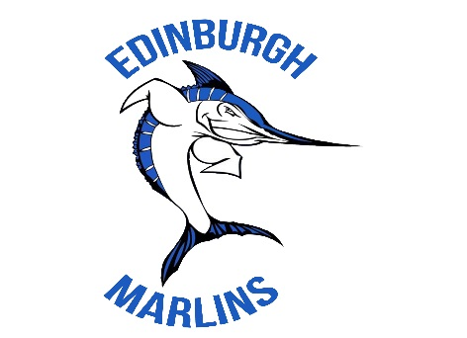

2016 MEDICAL RELEASE FORM

Please fill out this form completely and return it with the registration packet. Your child/ children will be unable to swim unless this form is on file.

Swimmer’s Name(s): Allergies/Medications/Other Info:

Emergency Contact Information
Parent’s Names | Home # | Cell #
Mother:
Father:
Emergency contacts/Relationship:
1.
2.
Doctor & Insurance Information
Doctor: | Phone #:
Insurance Company Name:
Insurance Phone Number:
Name of Policy Holder:
Policy #: | Group #:

MEDICAL WAIVER:
I, the undersigned, hereby certify that I am the parent or legal guardian of the above named swimmer(s). I hereby give my permission for any supervisor or member associated with the Edinburgh Marlins Swim Team to seek and give appropriate medical attention for my child/ children in the event of accident, injury and/or treatment.

I, the undersigned, hereby waive, release and forever discharge the Edinburgh Marlins Swim Team and its associated supervisors, board members, volunteers and coaches from all rights and claims for damages, injury, loss, including death, to person or property which may be sustained or occur during participation in swim team activities by the above named “Swimmers” whether or not said damages, injury, loss, including death is due to negligence. I acknowledge that I, the undersigned, have the right to remain on the swim deck for all practices and meets in order that I may attend to and oversee my Swimmers. I hereby acknowledge that my Swimmers are physically fit and mentally capable of participating in all Swim Team activities.
(Initial here)

Signature of Parent/Guardian Date
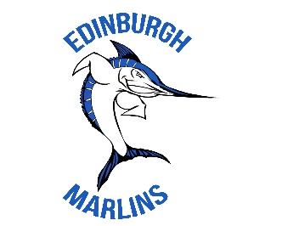
Edinburgh Marlins Swim Team
Volunteer Agreement

2016 Swim Season

Swimmer Name(s) and Age(s): __________________________________________________
___________________________________________________________________________ Parent Printed Names: ________________________________________________________
I understand that the Gwinnett County Swim League is a volunteer organization and that my participation is essential to the efficient operation of our team. I further understand that unless I am already on a committee, I am required to work 6 shifts/jobs (out of 12 possible shifts during our 6 regular swim meets) and 1 shift/job during the Practice Meet. I understand that I may have to fill different positions than the ones I select during registration. I also understand if I do not select a volunteer job that I will be assigned one by the Volunteer Coordinator.

Please select (6) meet shifts and (1) practice meet shift. Please note that this is NOT a guarantee but will be used to help setup desired scheduling.
 | “Mock” meet 5/19/16 | Meet 1  TBD | Meet 2 TBD | Meet 3 TBD | Meet 4 TBD | Meet 5 TBD | Meet 6 TBD
1st half
2nd half

I understand that it is my responsibility to find a replacement (phone numbers for all team members will be provided at a later date), in the event that I am unable to fulfill any of these obligations. I understand that if I do not fulfill one of my obligations that my child/ children will not be able to swim at the next scheduled meet.

 I am already on the following committee: ________________________________________

- I am NOT on a committee and I volunteer for the following:

(Please check the box next to the role requested and then CIRCLE the half that you would prefer to serve)

  - Clerk of Course – 1st Half / 2nd Half
  - Runner (home meets) –

  - Computer Score Table –
1st
Half / 2nd
Half

1st Half / 2nd Half
    - Staging –

  - Concessions (home meets) –
1st
Half /2nd
Half

1st Half / 2nd Half
  - Heat Ribbons (home meets) –
1st Half / 2nd Half
  - Relay Stager – 1st Half / 2nd Half
  - Ribbons – 1st Half / 2nd Half
  - Bullpen – 1st Half / 2nd Half
  - Starter (home meets) –
1st Half / 2nd Half
  - Stroke/Turn Judge – 1st Half / 2nd Half
  - Set-up/Take Down –
  - Timer – 1st Half / 2nd Half
1st
Half / 2nd
Half

Parents Signature _________________________________ Date ______________________

