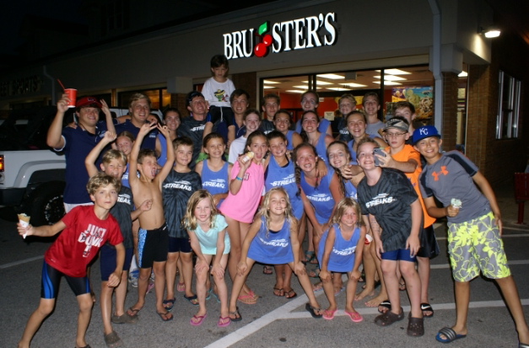
STREAKS SWIM-A-THON!
Riverside/North Harbor Streaks Swim to Fight Cancer
Thursday, June 23rd, 4pm-6pm
Riverside Swim and Tennis Club

Come out and help us “make waves to fight cancer” as we raise money for Swim Across America. Swim Across America (SAA) is an organization that connects swimmers all around the nation that all have the same goal of defeating cancer. We hope you can help us reach our goal of raising $5,000 through donations and participation in our Swim-A-Thon! Prizes will be awarded to the swimmer who raises the most money overall as well as the swimmers who swim the most laps for their age group (6&U, 7&8, 9&10, and 11&U) We hope to see you there!

SWIM. DONATE. VOLUNTEER.
www.swimacrossamerica.org/RNH

